**Module 1 – Project 2**

The following is a preview of the page you’ll create, which provides details of a non-profit, awareness footrace.

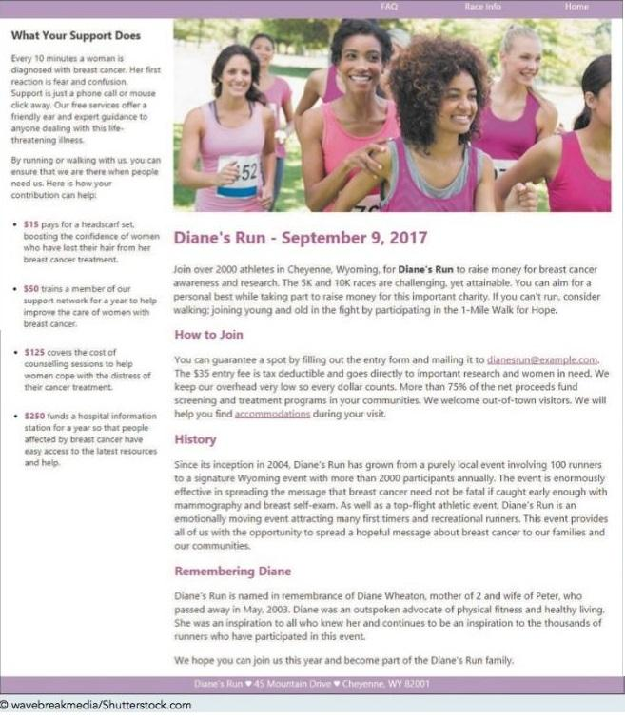 

The style sheet and graphics are provided for you. Your job is to write the HTML markup. Complete the following and **be sure to test frequently**!

1. Create a new static web project in Eclipse and name it **Module 1 – Project 02**. Import the project files into the WebContent folder.
2. Using your editor, open the **dr_index_txt.html**, **dr_info_txt.html**, and **dr_faq_txt.html** case3 folder. Enter ***your name*** and ***the date*** in the comment section of each file, and save them as **index.html**, **dr_info.html**, and **dr_faq.html** respectively.
3. Go to the index.html file in your HTML editor. Within the document head, add the following metadata:
   1. Set the character encoding of the file to **utf-8**.
   2. Insert the search keywords: **breast** **cancer**, **run**, **race**, and **charity**.
   3. Set the title of the document to **Diane’s Run**.
   4. Link the document to the dr_base.css and dr_layout.css style sheet files.
4. Within the document body, insert a **header** element, two **section** elements, and a **footer** element.
5. In the **header** element, insert a navigation list containing an unordered list with the items: **Home**, **Race** **info**, and **FAQ**. Link the items to the index.html, dr_info.html, and dr_faq.html files respectively.
6. The file dr_index.txt contains the text to be inserted into the Diane’s Run home page. Go to the **dr_index.txt** file in your text editor and copy the text from the first section of the file. Then, go to the **index.html** file in your HTML editor and paste it into the first **section** element.
7. Add the following markup to the content of the first **section** element:
   1. Mark the line *What Your Support Does* as an **h1** heading.
   2. Mark the next two paragraphs as paragraphs using the **p** element.
   3. Mark the four ways a contribution can help as an unordered list. Mark the dollar amounts of each list item using the **strong** element.
8. Return to the **dr_index.txt** file in your text editor, copy the text from the second section, then close the dr_index.txt file. Go to the **index.html** file in your HTML editor and paste the copied text within the second **section** element.
9. Within the second **section** element in the index.html file, add the following:
   1. Enclose the opening heading *Diane’s Run - September 9, 2017* within a *header* element and marked as an h1 heading. Directly above this heading, insert the inline image file dr_photo1.png with **Diane’s Run** as the alternate text of the image.
   2. Mark the first paragraph after the header as a paragraph. Mark the text *Diane’s Run* in this opening paragraph using the **strong** element.
   3. Mark the minor headings *How to Join*, *History*, and *Remembering Diane* as **h2** headings. Mark the other blocks of text as paragraphs.
10. Within the footer element, insert the following text:   
    **Diane’s Run ♥ 45 Mountain Drive ♥ Cheyenne, WY 82001**   
    where the ♥ character is inserted using the character code **9829**.
11. Save your changes to the file and then open **index.html** in your browser. Verify that the content and the layout of the page resemble that shown in the above image.
12. Go to the **dr_info.html** file in your HTML editor. Within the document head, link the page to the dr_base.css and dr_layout2.css style sheets.
13. Go to the **index.html** file in your HTML editor and copy the body header content. Then, go to the **dr_info.html** file in your HTML editor and paste the copied content into the document body. Repeat for the body footer so that the Racing Information page has the same navigation list and footer as the home page. Between the **header** and **footer** element, insert a **section** element.
14. Within the **section** element, insert a **header** element with the following content:
    1. Insert a paragraph with the text **Page last updated: Tuesday, August 29, 2017**. Mark the date using the **time** element with the **datetime** attribute equal to **2017-08-29**.
    2. Add the text **Race information** as an **h1** heading.
    3. Insert the inline image file dr_logo.png with **Diane’s Run** as the alternate text.
15. Go to the **dr_info.txt** file in your text editor. This file contains the text describing the race. Copy the content describing the race from the file, then close the dr_info.txt file. Go to the dr_info.html file in your HTML editor and paste the copied text into the **section** element, directly after the section header.
16. Mark the content of the **section** element as follows:
    1. Mark the opening block of text directly after the section header as a paragraph.
    2. Mark the headings *Race Times*, *Goodies and Stuff*, and *Notes* as h2 headings.
    3. Below each of the **h2** elements, mark the list of items that follows as an unordered list.
17. Save your changes to the file and then load dr_info.html in your browser to verify that the layout and content are readable.
18. Go to the **dr_faq.html** file in your HTML editor. Within the document head, link the page to the dr_base.css and dr_layout3.css style sheets.
19. Go to the **index.html** file in your HTML editor and copy the body header content. Then, go to the **dr_faq.html file** in your HTML editor and paste the copied content into the document body. Repeat with the body footer so that the FAQ page has the same navigation list and footer as was used in the home page. Between the **header** and **footer** element, insert a **section** element.
20. Within the **section** element, insert a **header** element with the **id** attribute **pagetop**. Within the header, insert the inline image file dr_logo.png with the alternate text **Diane’s Run** followed by the **h1** element with the text **Frequently Asked Questions**.
21. Go to the **dr_faq.txt** file in your text editor. This file contains a list of frequently asked questions followed by the question answers. Copy the text and then close the dr_faq.txt file. Then, go to the dr_faq.html file in your HTML editor and paste the copied text into the **section** element, directly after the section header.
22. Next, you’ll create a series of hypertext links between the list of questions and their answers within the same document. Make the following changes to the **section** element in the dr_faq.html file:
    1. Mark the 13 questions at the top of the section as an ordered list.
    2. Notice that below the ordered list you just created, the questions are repeated and each question is followed by its answer. Mark the text of those questions as an **h2** heading and the answer as a paragraph. Add an **id** attribute to each of the 13 **h2** headings with the first heading given the **id** **faq1**, the second heading **faq2**, and so forth down to **faq13** for the last **h2** heading.
    3. After the last answer, insert a paragraph with the text **Return to the top** and mark the text as a hypertext link pointing to the **header** element with the id **pagetop**.
    4. Return to the ordered list at the top of the section that you created in Step a. Change each item in the ordered list to a hypertext link pointing to the **h2** heading containing the question’s answer that you created in Step b. For example, the first question *How do I sign up?* should be linked to the **h2** heading with the faq1 **id**.
23. Save your changes to the file and then open **dr_faq.html** in your browser. Verify that by clicking a question within the ordered list, the browser jumps to that question’s answer. Further, verify that clicking the Return to the Top link at the bottom of the page causes the browser to return to the top of the page.
24. Return to the **index.html** file in your HTML editor. Add the following two hypertext links to the *How to Join* paragraph in the second **section** element:
    1. Change the e-mail address *dianesrun@example.com* to an e-mail link with the subject heading Entry Form.
    2. Change the word accommodations to a hypertext link pointing to the element with the **id** faq13 in the dr_faq.html file.
25. Save your changes to the file and reload dr_index.html in your browser. Verify that clicking the e-mail link brings up your e-mail program with the e-mail address and the subject heading already filled in.
26. Click the accommodations hypertext link and verify that the browser goes to the last answer on the FAQ page. 26.
27. Verify that you can jump between all three pages by clicking the navigation links at the top of the page.